|  |  |
| --- | --- |
|  | **Medicine Monitoring System**  **Technical Design Document**  **1.0** |
| |  |  |  |  | | --- | --- | --- | --- | |  | **Prepared By / Last Updated By** | **Reviewed By** | **Approved By** | | **Name** | Person 1 | Person 2 | Person 3 | | **Role** | Sarth Sharma | Payush Bathla | Parth Sharma | | **Signature** |  |  |  | | **Date** | 15-Apr-2019 | 16-Apr-2019 | 17-Apr-2019 | |
|  |

Table of Contents

1.0 Introduction 3

1.1 Purpose of this document 3

1.2 Scope 3

1.3 Intended Audience 3

1.4 Definition & Acronyms 3

2.0 Conventions and Standards Followed 4

3.0 Assumptions, Dependencies and Risks 4

3.1 Assumptions: 4

3.2 Dependencies: 4

4.0 Schematic Diagram 4

5.0 Use Case Realization 5

5.1.1 User Registration 5

a. Functional Requirement 5

b. UI Validations 6

c. UI Controls 6

d. UI Design 6

6.0 Database Design 7

6.1 Data Model 7

6.2 Tables Structure 8-10

1. Change Log 11

## 1.0 Purpose of this document

The purpose of the detail design document is to define the detailed design for all the components of Medicine Monitoring System that are specified in the Business Requirement/Use case document. All the low level components, interfaces and integrations are detailed out in this document.

## Scope

This sub-section shall state the scope of this detailed design document

* Create and maintain admin credentials.
* Create and maintain branch admin record.
* Add and update medicine records.
* Accept or decline branch admin medicine request.
* Updating the status of request for medicine.
* Storing stock details of medicines.
* Storing the requests raised by branch admin and the response from the admin.

## Intended Audience

*The intended audience for this document are*

* All member of the project.
* Delivery Assurance Group.

## Definition & Acronyms

|  |  |
| --- | --- |
| **Acronyms** | **Definitions** |
| MMS | Medicine Monitoring System |

# Conventions and Standards Followed

The modules under scope needs to adhere to the coding standards and guidelines

# Assumptions, Dependencies and Risks

## Assumptions:

* Once the application is built the Medicine Monitoring System will manually load the user list into the system.
* There will be no concurrent users for the application. The Branch Admin profile will be maintained by the Admin.
* Any changes to the design mentioned in the BRD would be taken as a Change Request

## Dependencies:

* Availability of database design characteristics & access shall be defined by the
* Resource availability throughout each of the sprint

# Schematic Diagram

A schematic, or schematic diagram, is a representation of the elements of a [system](https://en.wikipedia.org/wiki/System) using abstract, graphic [symbols](https://en.wikipedia.org/wiki/Symbol) rather than realistic pictures. It gives an overview of overall system



*The above pic is only an example and not representational of the Medicine Monitoring System*

# Use Case Realization

### User Registration

### Functional Requirement

. Login Page checks the authentication of the user and directs the user to the respective page. User will be accessed with functionalities to add and manage Branch Admin details, handle requests and manage and add medicine as well as stocks.

### UI Validations

* User Id and Password fields are mandatory.
* Invalid User Id or password should not allow the user to get into the system.

### UI Controls

|  |  |  |  |  |
| --- | --- | --- | --- | --- |
| **#** | **UI Component** | **Type** | **Name** | **Details** |
| 1 | Admin Id | Label | label_for Admin _Id |  |
| 2 | Admin | Text field | Text field Admin Id | To enter admin_id |
| 3 | Password | Label | Label_for_password |  |
| 4 | password | Text field | Text field_password | To enter password |

### UI Design



# Database Design

## Data Model

### The following is a schematic view of the database design

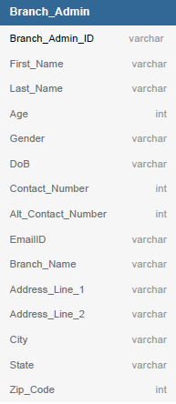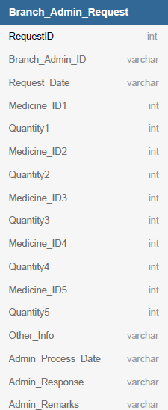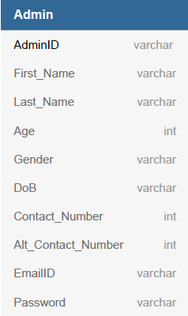

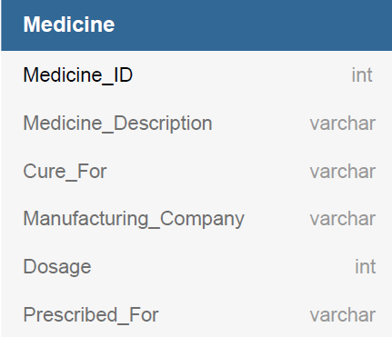

## Tables Structure

**Admin:**

|  |  |  |  |
| --- | --- | --- | --- |
| **Column Name** | **Data Type** | **Length** | **Nulls** |
| Admin ID | Alphabetic | 10 | N |
| First Name | Alphabetic | 50 | N |
| Last Name | Alphabetic | 50 | N |
| Age | Numeric | 2 | N |
| Gender | Drop Down |  | N |
| DoB | Alphanumeric | 10 | N |
| Contact Number | Numeric | 10 | N |
| Alt Contact Number | Numeric | 10 | Y |
| Email ID | Alphanumeric | 50 | N |
| Password | Alphabetic | 10 | N |

**Medicine:**

|  |  |  |  |
| --- | --- | --- | --- |
| **Field Name** | **Data Type** | **Length** | **Nulls** |
| Medicine ID | Numeric | 8 | N |
| Medicine Description | Alphabetic | 200 | N |
| Cure For | Alphabetic | 100 | N |
| Manufacturing Company | Alphabetic | 50 | N |
| Dosage | Numeric | 3 | N |
| Prescribed For | Alphabetic | 1 | N |

**Branch Admin:**

|  |  |  |  |
| --- | --- | --- | --- |
| **Column Name** | **Data Type** | **Length** | **Nulls** |
| Branch Admin ID | Alphabetic | 10 | N |
| First Name | Alphabetic | 50 | N |
| Last Name | Alphabetic | 50 | N |
| Age | Numeric | 2 | N |
| Gender | Drop Down |  | N |
| DoB | Alphanumeric | 10 | N |
| Contact Number | Numeric | 10 | N |
| Alt Contact Number | Numeric | 10 | Y |
| Email ID | Alphanumeric | 50 | N |
| Branch Name | Alphabetic | 50 | N |
| Address Line 1 | Alphanumeric | 100 | N |
| Address Line 2 | Alphabetic | 100 | Y |
| City | Alphabetic | 50 | N |
| State | Alphabetic | 50 | N |
| Zip Code | Numeric | 10 | N |

**Branch Admin Request:**

|  |  |  |  |
| --- | --- | --- | --- |
| **Field Name** | **Data Type** | **Length** | **Nulls** |
| Request ID | Numeric | 8 | N |
| Branch Admin ID | Alphabetic | 10 | N |
| Request Date | Alphanumeric | 10 | N |
| MedicineID1 | Numeric |  | N |
| Quantity1 | Numeric | 3 | N |
| MedicineID2 | Numeric |  | Y |
| Quantity2 | Numeric | 3 | Y |
| MedicineID3 | Numeric |  | Y |
| Quantity3 | Numeric | 3 | Y |
| MedicineID4 | Numeric |  | Y |
| Quantity4 | Numeric | 3 | Y |
| MedicineID5 | Numeric |  | Y |
| Quantity5 | Numeric | 3 | Y |
| Other Info | Alphabetic | 200 | Y |
| Admin process date | Alphanumeric | 10 | Y |
| Admin Response | Alphabetic | 1 | Y |
| Admin remarks | Alphanumeric | 300 | Y |

# Change Log

*Please note that this table needs to be maintained even if a Configuration Management tool is used.*

|  |  |  |  |  |
| --- | --- | --- | --- | --- |
| Version Number | Changes made | | | |
| V1.0 | *<First version>* | | | |
| V1.1 | *<If the change details are not explicitly documented in the table below, reference should be provided here>* | | | |
| Page no | Changed by | Effective date | Changes effected |
|  |  |  |  |
|  |  |  |  |
|  |  |  |  |
|  |  |  |  |
| V1.2 | *<If the change details are not explicitly documented in the table below, reference should be provided here>* | | | |
| Page no | Changed by | Effective date | Changes effected |
|  |  |  |  |
|  |  |  |  |
|  |  |  |  |
|  |  |  |  |